﻿Unit 3 AD/AS Equilibrium Questions

Change in AD/AS
- Following a decrease in aggregate demand, an increase in unemployment will result if
prices increase and real wages decrease
the aggregate supply curve is vertical
prices and wages quickly adjust to equilibrium levels
short-run aggregate supply also increases
prices and nominal wages are slow to adjust in the short run
- Stagflation is caused by
A an increase in imports
B an increase in aggregate demand
C a decrease in aggregate demand
D a decrease in aggregate supply
E an increase in aggregate supply
- In the long run, if aggregate demand decreases, real gross domestic product (GDP) and the price level will change in which of the following ways?
 | RGDP | Price Level
A | Decrease | Decrease
B | Decrease | Increase
C | No change | Decrease
D | Increase | Decrease
E | No change | Increase

- An increase in which of the following would most likely cause the gross domestic product of a country to decrease in the short run?
- Government spending
- Imports
- Money supply
- Consumption spending by households
- Investment spending by domestic firms
- Which of the following best explains how an economy could simultaneously experience high inflation and high unemployment?
- The government increases spending without increasing taxes.
- The government increases taxes without increasing spending.
- Inflationary expectations decline.
- Women and teenagers stay out of the labor force.
- Negative supply shocks cause factor prices to increase.
- An increase in the price of oil, an important input to production, will result in which of the following in the short run?
- A decrease in the price level
- A decrease in short-run aggregate supply
- A decrease in unemployment
- An increase in real wages
- An increase in aggregate demand
- An economy is in long-run macroeconomic equilibrium. What will be the short-run effects of an increase in investment spending?
- An increase in real output, an increase in unemployment, and a decrease in the price level
- An increase in real output, an increase in unemployment, and an increase in the price level
- An increase in real output, a decrease in unemployment, and an increase in the price level
- A decrease in real output, a decrease in unemployment, and a decrease in the price level
- A decrease in real output, a decrease in unemployment, and no change in the price level
﻿
- If the short-run aggregate supply curve is upward sloping, which of the following will cause inflation?
A An increase in long-run aggregate supply
B An increase in short-run aggregate supply
C An increase in aggregate demand
D A decrease in aggregate demand
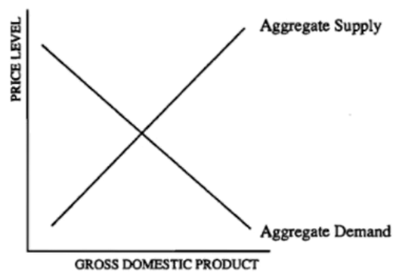
E A decrease in aggregate demand and an increase in aggregate supply
- According to the graph above, which of the following will necessarily result in a decrease in output?
I. A rightward shift of the aggregate demand curve
II. A leftward shift of the aggregate demand curve III. A rightward shift of the aggregate supply curve IV. A leftward shift of the aggregate supply curve
- I only
- III only
- I and III only
- II and III only
- II and IV only

- ﻿Which of the following will cause an increase in real output in the short run?
- A decrease in productivity
- A decrease in wages
- A decrease in government expenditure
- An increase in reserve requirements
- An increase in the discount rate
- Which of the following events will most likely cause an increase in both the price level and real gross domestic product?
- The interest rate increases.
- Exports increase.
- Income taxes increase.
- Crude oil prices decrease.
- Inflationary expectations decrease.
- ﻿Assume that the aggregate supply curve is upward sloping. If both aggregate supply and aggregate demand increase, what will happen to the equilibrium output and price level?
 | RGDP | Price Level
A | Decrease | Decrease
B | Decrease | Increase
C | Indeterminate | Decrease
D | Increase | Indeterminate
E | Increase | Increase
- Assume that an economy is currently in long-run equilibrium and the short-run aggregate supply curve is upward sloping. An adverse supply shock, such as a drought, will most likely cause which of the following to the economy in the short run?
- A decrease in the price level and a decrease in the nominal wage
- A decrease in the price level and an increase in the nominal wage
- An increase in the price level and an increase in the nominal wage
- An increase in the price level and an increase in the real wage
- An increase in the price level and a decrease in the real wage
- ﻿A contractionary supply shock would most likely result in
- an increase in aggregate demand
- an increase in national income
- an increase in gross domestic product
- a decrease in the general price level
- a decrease in employment
- The intersection of the aggregate supply curve and the aggregate demand curve occurs at the economy's equilibrium level of
- real investment and the interest rate
- real disposable income and unemployment
- real national output and the price level
- government expenditures and taxes
- imports and exports
- Which of the following will remain unchanged when the price level decreases?
- Inflationary expectations
- Aggregate quantity demanded
- Long-run aggregate supply
- Nominal wages
- Nominal output
- ﻿Inflation

Inflation
- Which of the following changes will necessarily cause inflation?
- A decrease in aggregate demand and a decrease in short-run aggregate supply.
- A decrease in aggregate demand and an increase in short-run aggregate supply.
- A decrease in aggregate demand with no change in short-run aggregate supply.
- An increase in aggregate demand and a decrease in short-run aggregate supply.
- An increase in aggregate demand and an increase in short-run aggregate supply.
- Which of the following would generate cost-push inflation?
A An increase in the price of labor
B A decrease in the price of energy
С An increase in household consumption
D A decrease in government spending
E An increase in the money supply
- An ongoing increase in the price of oil will result in
- demand-pull inflation
- cost-push inflation
- expansionary fiscal policy
- a decrease in the prices of substitute forms of energy
- deflation
- Stagflation is most likely to be caused by
- an increase in aggregate demand
- a decrease in aggregate demand
- an increase in aggregate supply
- a decrease in aggregate supply
- a large increase in the money supply
- Policies intended to reduce demand-pull inflation are most likely to increase which of the following in the short run?
- Gross domestic product
- The labor force participation rate
- The price level
- Unemployment
- Wage levels
- Which of the following would most likely lead to cost-push inflation in the short run?
- A decrease in labor productivity
- A decrease in income tax rates
- A decrease in consumers' and businesses' optimism about future economic activity
- An increase in government deficit spending to stimulate a weak economic recovery
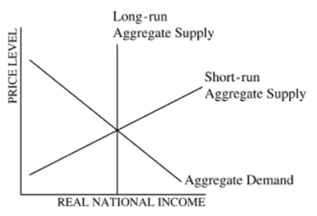
- Discovery of new sources of energy
- ﻿Assume that the economy is at full-employment equilibrium in the diagram shown above. Which of the following would lead to stagflation?
- A leftward shift of the short-run aggregate supply curve only
- A rightward shift of the short-run aggregate supply curve only
- A leftward shift of the aggregate demand curve only
- A rightward shift of the aggregate demand curve only
- A rightward shift in both the short-run aggregate supply curve and the aggregate demand curve
- ﻿Based on the graph above, demand-pull inflation is caused by a movement from
- SRAS1 to SRAS2
- SRAS2 to SRAS1
- AD1 to AD2
- AD2 to AD1
- Yf to Y1
Output Gaps, Unemployment, Potential Output etc. LR vs SR
- In the AD - AS model, which of the following is true?
- The economy is in an inflationary gap when the short-run equilibrium real output is below the long-run equilibrium real output.
- The economy is in an inflationary gap when the short-run equilibrium real output is at the long-run equilibrium real output.
- The economy is in a recessionary gap when the short-run equilibrium real output is at the long-run equilibrium real output.
- The economy is in a recessionary gap when the short-run equilibrium real output is below the long-run equilibrium real output.
- The economy is in a recessionary gap when the short-run equilibrium real output is above the long-run equilibrium real output.

- Assume that the United States economy is currently in long-run equilibrium.
a. Draw a correctly labeled graph of aggregate demand and aggregate supply and show each of the following.
- The long-run aggregate supply curve
- The current equilibrium output and price levels, labeled as Yg and PLE, respectively
b. Assume that the government increases spending on national defense without raising taxes.
- On your graph in part (a), show how the government action affects aggregate demand.
- How will this government action affect the unemployment rate in the short run? Explain.
c. Assume that the economy adjusts to a new long-run equilibrium after the increase in government spending
- How will the short-run aggregate supply curve in the new long-run equilibrium compare with that in the initial long-run equilibrium in part (a)? Explain.
- On your graph in part (a), label the new long-run equilibrium price level as PL2.

Output Gaps, Unemployment, Potential Output, LR vs SR Equilibrium
﻿
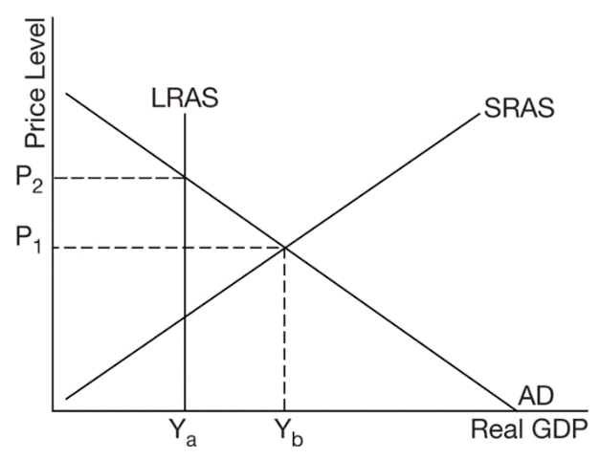
- Based on the diagram above, which of the following describes the short-run equilibrium?
- The economy is operating at full employment.
- The economy is operating below full employment.
- The economy is operating above full employment.
- There will be downward pressure on the price level.
- There recessionary gap.
﻿
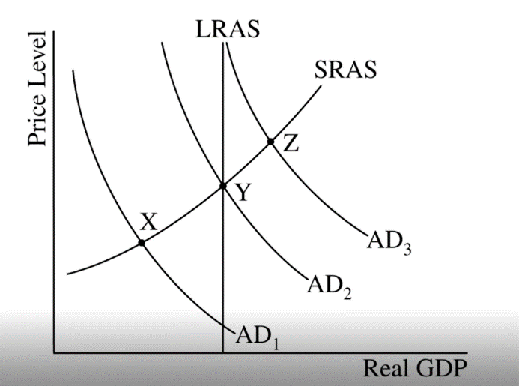
- Use the ADAS graph shown above to choose the most correct statement.
- At point Z, the economy has cyclical unemployment.
- At point Z, the economy is in long run equilibrium
- At point Y, the natural rate of unemployment is zero.
- At point x, the economy is experiencing a recessionary gap.
- At point X, there is no frictional unemployment.
- An economy is currently operating at the full-employment level of output. Which of the following would result in a recessionary gap in the short run
- An increase in imports
- An improvement in the productivity of labor
- An increase in money supply
- A positive supply shock
- A decrease in income tax rates
- Assume an economy is in a long-run equilibrium. Following a decrease in aggregate demand, which of the following is true in the short run
- The unemployment rate is equal to the natural rate of unemployment, and the rate of inflation is rising.
- The unemployment rate is greater than the natural rate of unemployment, and the rate of inflation is rising.
- The unemployment rate is greater than the natural rate of unemployment, and the rate of inflation is declining.
- The unemployment rate is lower than the natural rate of unemployment, and the rate of inflation is declining.
- The unemployment rate is lower than the natural rate of unemployment, and the unemployment rate is rising.
﻿
- An economy is at full-employment equilibrium. If consumers and firms become more optimistic about future income and profits, which of the following will occur in the short run?
- Aggregate demand will shift rightward, increasing real output and decreasing the price level.
- Aggregate demand will shift rightward, decreasing real output and increasing the price level.
- Aggregate demand will shift rightward, increasing real output and the price level.
- Short-run aggregate supply will shift rightward, increasing real output and the price level.
- Short-run aggregate supply will shift rightward, decreasing real output and the price level.
﻿
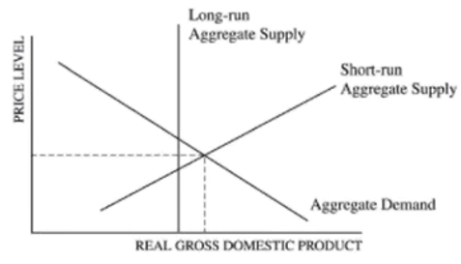
- According to the graph above, which of the following is true about the long-run equilibrium of the economy depicted?
- The economy is in long-run equilibrium.
- The aggregate demand curve will shift to the left to restore long-run equilibrium.
- The long-run aggregate supply curve will shift to the right to restore long-run equilibrium.
- Without a fiscal policy stimulus, the economy will remain in a recession.
- As wages increase, the short-run aggregate supply curve will shift to the left to restore long-run equilibrium.
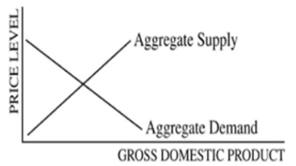
﻿
- According to the graph above, an increase in aggregate supply will most likey cause income and empoyment to chage in which of the following ways.
Income Employment
- Decrease Decrease
- Decrease Increase
- No change Increase
- Increase Decrease
- Increase Increase

- The graph below shows the macroeconomic conditions of Wattsonia. Many economists estimate that the natural rate of unemployment is 6 percent.
If this is true and the current rate of unemployment is 5.1 percent, in what range of real gross domestic product is the economy currently producing
- Less than Y1
- At Y1
- At Y2
- Greater than Y, and less than Y2
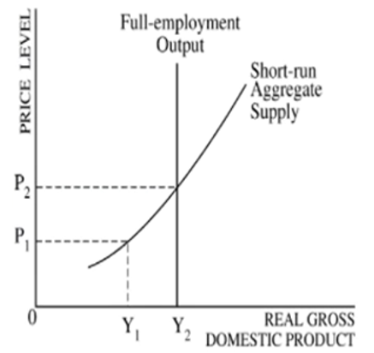
- Greater than Y2
- Assume a country's economy is currently in long-run equilibrium. What is the long-run effect of an increase in aggregate demand?
- A decrease in the unemployment rate
- A decrease in the inflation rate
- A decrease in the long-run aggregate supply
- An increase in the price level
- An increase in the money supply
1 | E | 11 | B | 21 | D | 31 | C
2 | D | 12 | D | 22 | A | 32 | E
3 | C | 13 | E | 23 | A | 33 | B
4 | B | 14 | E | 24 | C | 34 | D
5 | E | 15 | C | 25 | D | 35 | D
6 | B | 16 | C | 26 |  | 36
7 | C | 17 | D | 27 | C | 37
8 | C | 18 | A | 28 | D | 38
9 | E | 19 | B | 29 | A | 39
10 | B | 20 | D | 30 | C | 40

